Hooke’s Law is a scientific law that says the restoring force required to compress or stretch a spring is directly proportional to the distance the spring is deformed.

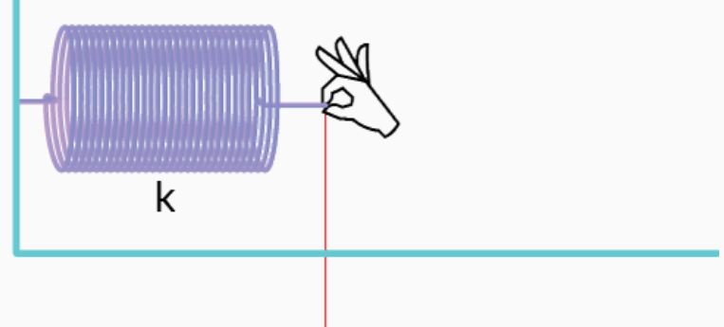
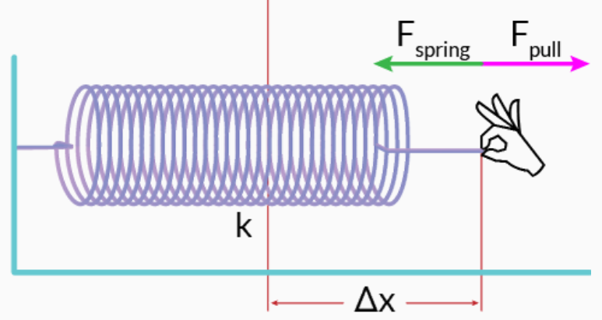

The formula form of Hooke’s Law is: F = -k·Δx, where
F is the restoring force of the spring
k is the proportionality constant called the ‘spring constant’
Δx is the change in the spring’s position due to the deformation.
The minus sign is there to show the restoring force is opposite to the deforming force. The spring tries to restore itself to its undeformed state. When a spring is pulled apart, the spring pulls back against the force of the pull. When a spring is compressed, the spring pulls back against the compression.
Hooke’s Law:
The magnitude of spring force is directly proportional to compression/stretch F = k·Δx

Question 1: How much force is needed to pull a spring with a spring constant of 20 N/m a distance of 25 cm?

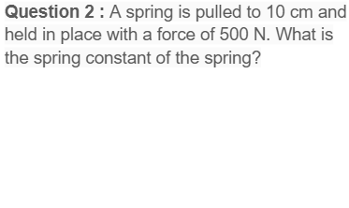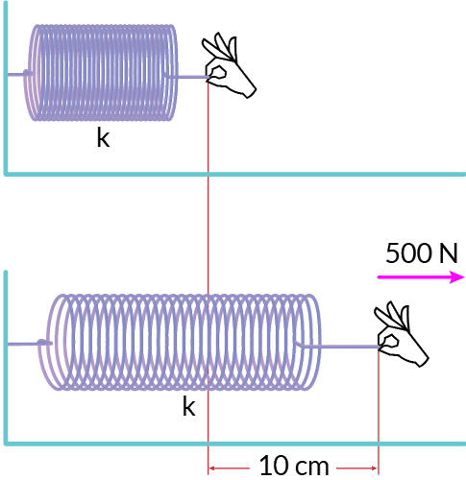
Question 3: A spring with a spring constant of 750 N/m is compressed by a force of 15N, the original length is 10 cm when the spring is not compressed/stretched. How long is the spring after compression?

Question 4: A spring with a spring constant of 800 N/m is stretched by a force of 56N to a length of 28cm, how long is the original length of the spring?

Elastic Potential Energy - Energy in Hooke’s Law of Deformation
To produce a deformation, work must be done. That is, a force must be exerted through a distance, whether you pluck a guitar string or compress a car spring. If the only result is deformation, and no work goes into thermal, sound, or kinetic energy, then all the work is initially stored in the deformed object as some form of potential energy. The potential energy stored in a spring is:

Elastic Potential Energy: ${PE}_{s}=\frac{1}{2}kx^{2}$
where k is the spring constant, and x is actually $Δx$ ,the stretched or compressed length of the spring.

Recall the gravitational potential energy we had before: $PE_{g}=mgh$
Where h is actually $Δh$ , the change of the height from the 0 reference level of GPE.

Just like gravity, spring force is also a conservative force. That is, work-done by the spring force is independent to its path. Thus, in an ideal spring system, the mechanical energy, or the sum of kinetic energy and elastic potential energy is conserved.

Question 5: A spring with a spring constant of 750 N/m is compressed by a force of 15N, the original length is 10 cm. What is the elastic potential energy gained at this compression?

Question 6: A spring with a spring constant of 800 N/m is stretched by a force of 56N to a length of 28cm, What is the elastic potential energy gained at this stretch?

Example 1
Use a toy gun’s spring mechanism to answer questions: (a) How much energy is stored in the spring of a tranquilizer gun that has a force constant of 50.0 N/m and is compressed 0.150 m? (b) If friction is neglected, at what speed will a 2.00-g projectile be ejected from the gun?
Kinetic Energy: $kE=\frac{1}{2}mv^{2}$, Elastic Potential Energy: ${PE}_{s}=\frac{1}{2}kx^{2}$
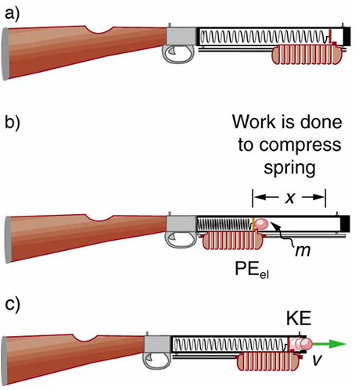

Example 2: A spring jumper toy has a spring measured 4.50 cm. Its mass is 2.80-g. The toy is pushed down to a length of 1.80 cm and released. It jumps a height of 1.30m. Find (a) the elastic potential energy the spring has when it’s pushed down (b) the gravitational potential energy it has when reaching the highest point (c) the spring constant (d) the initial velocity at the time the toy is launched



Effective Spring Constant

Example 3: Hook’s Law states that the magnitude of spring force is $F=k⋅Δx$, where k is the spring constant and $Δx$ is the compression or stretch of the spring. For each of the following arrangements of two springs, determine the effective spring constant Keff, This is the force constant of a single spring that would produce the same force on the blocks as the pair of springs shown in each case. Determine Keff in each case.

a) Springs are connected in parallel b) Springs are connected in series
$k_{1}=300N/m, k_{2}=200N/m$ $k_{1}=300N/m, k_{2}=200N/m$
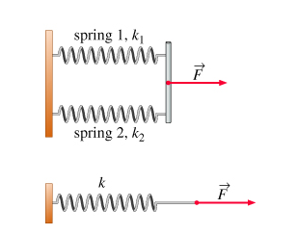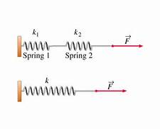
$K_{eff}=$ __________ $K_{eff}=$ __________

c) Springs are connected at the t two ends of an object
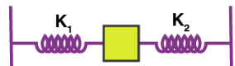

Summary:
For springs connected in parallel, the effective spring constant is:
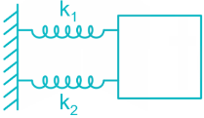 $K_{eff}=k_{1}+k_{2}$

For springs connected in series, the effective spring constant is:
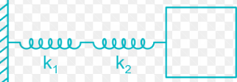 $\frac{1}{K_{eff}}={\frac{1}{k_{1}}}_{}+{\frac{1}{k_{2}}}_{}$, or: $K_{eff}={\frac{k_{1}⋅k_{2}}{k_{1}+k_{2}}}_{}$

Hooke’s Law $F=-kx$ Elastic Potential Energy: ${PE}_{s}=\frac{1}{2}kx^{2}$ Kinetic Energy: $kE=\frac{1}{2}mv^{2}$

Problems of Energy Conservation
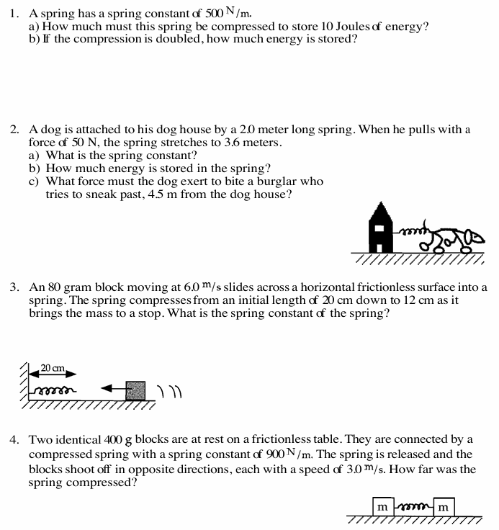

Hooke’s Law $F=-kx$ Elastic Potential Energy: ${PE}_{s}=\frac{1}{2}kx^{2}$ Kinetic Energy: $kE=\frac{1}{2}mv^{2}$
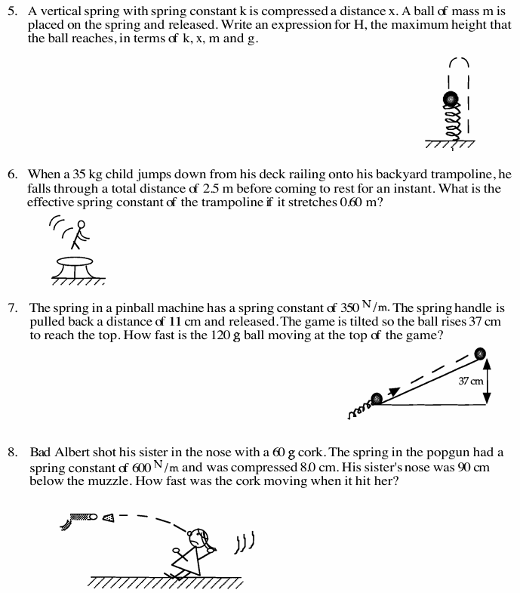
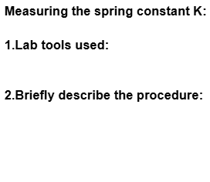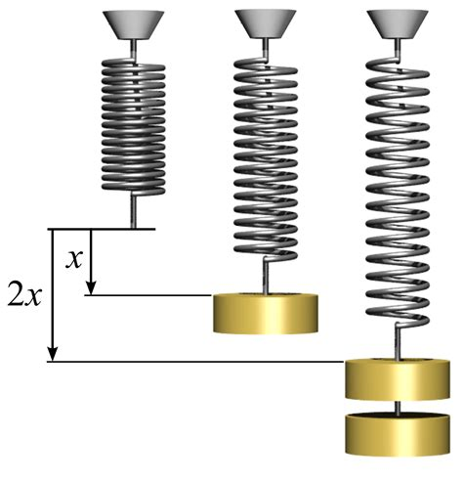
3. Data and Graphs: Plot F on the y-axis, ᐃx on the x-axis, then do the best fit line to obtain K

Measuring the Spring Constant K
Must write the units of each measurements, average value is one decimal more than your measurements
 | 1 | 2 | 3 | 4 | 5 | 6
Force applied F
Spring Length x
ᐃx (Change of x)

Graph: Your Vertical Axis: _________ Your Horizontal Axis: __________

The spring constant of the spring is the slope of the best-fitted line: k = _________

